1. **DATA DESCRIPTION**
2. **Input to recommendation/Machine learning**

From http://www.kaggle.com/c/msdchallenge/data, we have downloaded the following file:

T**he core data: triplets (user, song, play count), is**

● kaggle_visible_evaluation_triplets.txt

The first file contains the visible part of the testing data.

Each user’s listening history is defined in terms of these triplets.

There are ~1,110,000 unique users.

1. **HDF5[Hierarchical data format] files fort songs metadata, compressed file format (~280GB)**

From <https://labrosa.ee.columbia.edu/millionsong/pages/getting-dataset>, where we can download the

Contains all the metadata for particular ‘Track’ is like:-

1. Artist Id, Artist Location
2. Tempo of song
3. Loudness
4. Dance ability
5. Energy, etc.

● songs_dataset.csv

We executed a Java program ‘HDF5getters.java’ to retrieve the data and upload on ‘MongoDB’, which is our database in the E2E web service being provided.

Lib required: hdf-java-2.6.1



There is also an AWS volume in east-America region which we attached to our t2.xl Ubuntu instance to fetch the data by running this above ‘HDF5getters.java’ program.

(snapshots in point 8.)

1. **Trending data – [Derived Input], by a MapReduce[attaching CODE for it]**

It is a derived data helping us to recommend better.

We have written a Map Reduce to do ‘groupBy’ the ‘Song’ based on ‘SongId’ and aggregated Reducer output as ‘Total_Number_Of_Times_Song_Played_OverAll’and insert the MapReduce output with mahout output in the mongoDB.



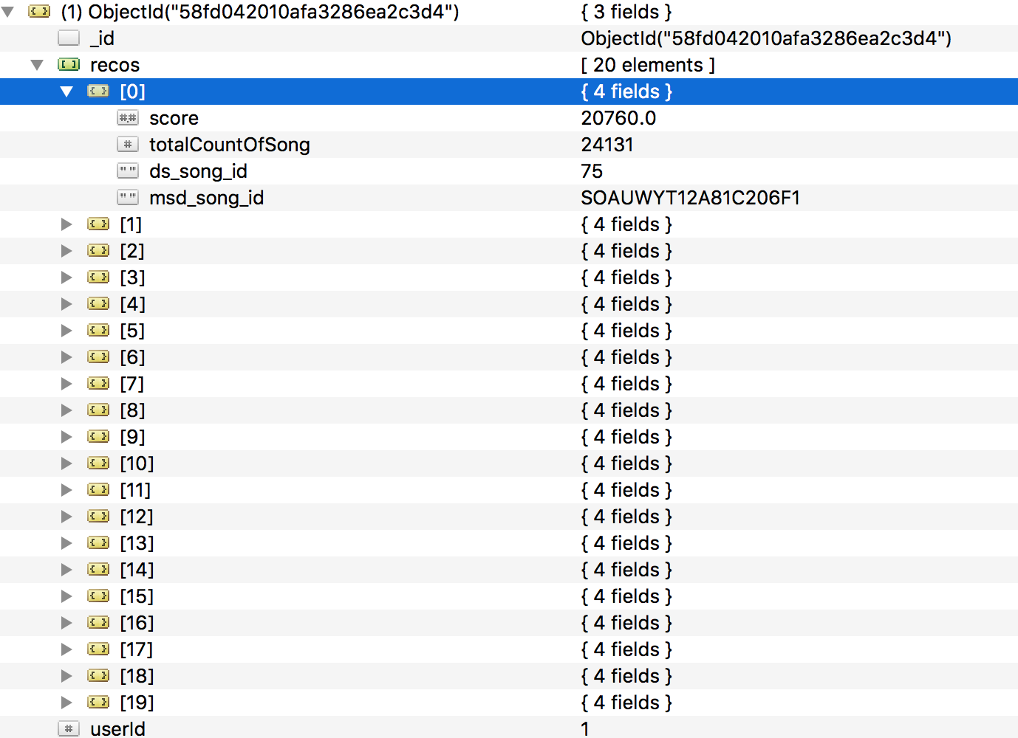

1. **TASKS**
2. **Helper Function in JAVA to bring the triplet in the desired format**



|  |  |  |
| --- | --- | --- |
| User Id | Track Id | Play Count |
| fd50c4007b68a3737fe052d5a4f78ce8aa117f3d | SOBONKR12A58A7A7E0 | 1 |
| 9be82340a8b5ef32357fe5af957ccd54736ece95 | SOHGGAH12A58A795BE | 15 |

In the format of:

|  |  |  |
| --- | --- | --- |
| User Id | Track Id | Play Count |
| 1 | 1 | 1 |
| 10 | 22 | 15 |

For the Mahout recommendation format.

1. **Normalizing the ‘Play Count’ values to simulate ‘Ratings’ – [Log Transformation]**

For better recommendation and take play count into appropriate considerations, we applied the ‘LOG-2 transformation’ in R.

**dataFrame <- read.csv("mahoutInput.csv")**

**dataFrame [,3] <- log(dataFrame [3], 2)**

1. **Running a helper/Map reduce to group songs and fetch total count across platform which will help me decide ‘MOST TRENDING SONGS’**



Inside mongoDb, do

**eachReco.put("totalCountOfASong", CountOfCurrentSong);**

1. **Ran Mahout Recommendation Algorithm, optimized by utilizing all the cores of Machine, using various combinations**

Other than the commands ran from the Hadoop configuration, We have these different runs to improve the efficiency.

**Command:**

**bin/hadoop jar mahout-core-0.7-job.jar org.apache.mahout.cf.taste.hadoop.item.RecommenderJob -Dmapred.input.dir=input_reco/input_to_mahout.csv -Dmapred.output.dir=output_mahout_reco --numRecommendations 30 --booleanData true --similarityClassname SIMILARITY_COOCCURRENCE**

|  |  |  |  |  |  |  |
| --- | --- | --- | --- | --- | --- | --- |
| **Algorithm used** | **Attribute** | **Correlation** | **Range of Dependent variable** | **RMSE/**  **NCDG** | **Accuracy** | **Observation** |
| Mahout  Jar  - as MAP-REDUCE | Actual Play Count | PearsonCorrelationSimilarity(model) | 1-646 | 186.93 | 71.4% | Actual data has some patterns hence we observe a good accuracy |
| Mahout  -as  Actual java  program | Log2 normalization of Play Count, | LogLikelihoodSimilarity(model) | 0-5 | 1.8 | 69.5% | Normalization brought noise in terms of mapping low values -> 0, thus the accuracy reduced |
| Mahout  -as  Actual java  program | Log2 normalization of Play Count, | EuclideanDistanceSimilarity  (model) | 0-5 | 1.6 | 73.5% | Euclidean distance improved the Similarity matrix, thus better accuracy |
| Mahout  -as  Actual java  program | Clustering the ‘Play Count’ boosting the values to fit to a cluster | PearsonCorrelationSimilarity(model) | 1-3 | NaN | NaN | We tried to debug the code and run it a couple of times but couldn’t figure out the fault in data |
| Matchbox Recommendation  -On Azure ML STUDIO | Log2 normalization of Play Count | relevance of the recommended entities  DCGk=∑i=1k2reli−1log2(i+1) | 1-5 | 0.79/1.00 | - | It is using a hybrid recommendation  Of  ‘user-user’  & ‘item-item’ based similarity |

**TRIALS**

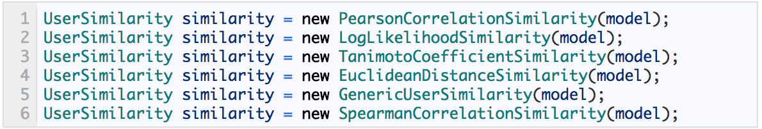

EuclideanDistanceSimilarity(model) – RMSE – 1.6[range of Dependent Variable – 0-5]



LogLikelihoodSimilarity (model) – RMSE – 1.8[range of Dependent Variable – 0-5]

**\**

1. **Our logic to suggest 3 playlists**
   1. **Playlist 1:- These might cheer you up**

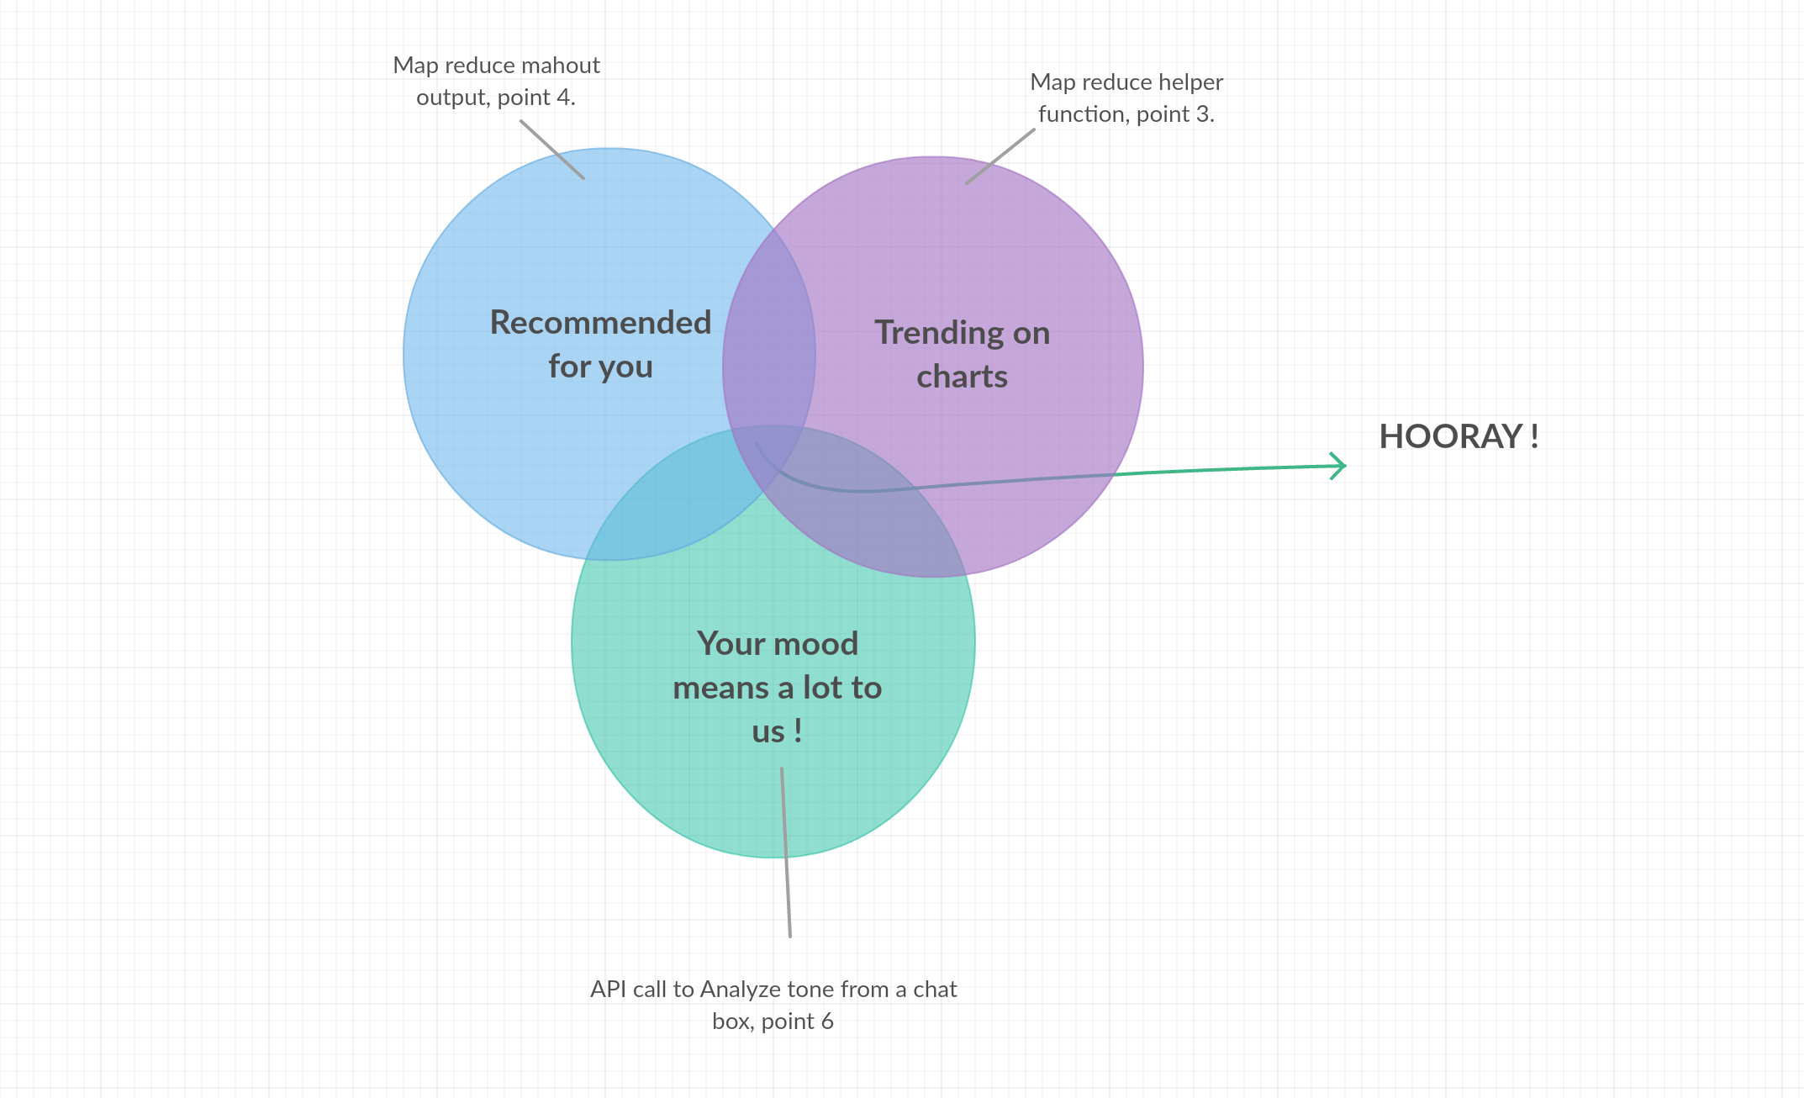

* 1. **Playlist 2:- These match your preferences**

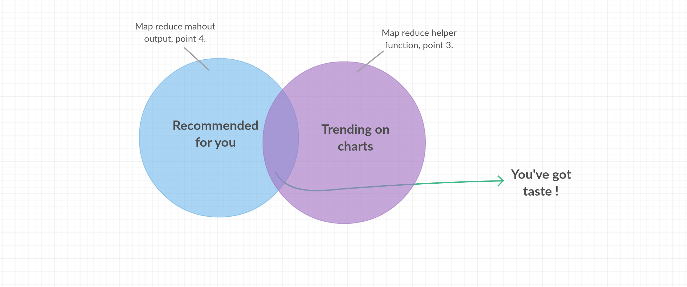

**5.3 Playlist 3:- These are recommended for you**

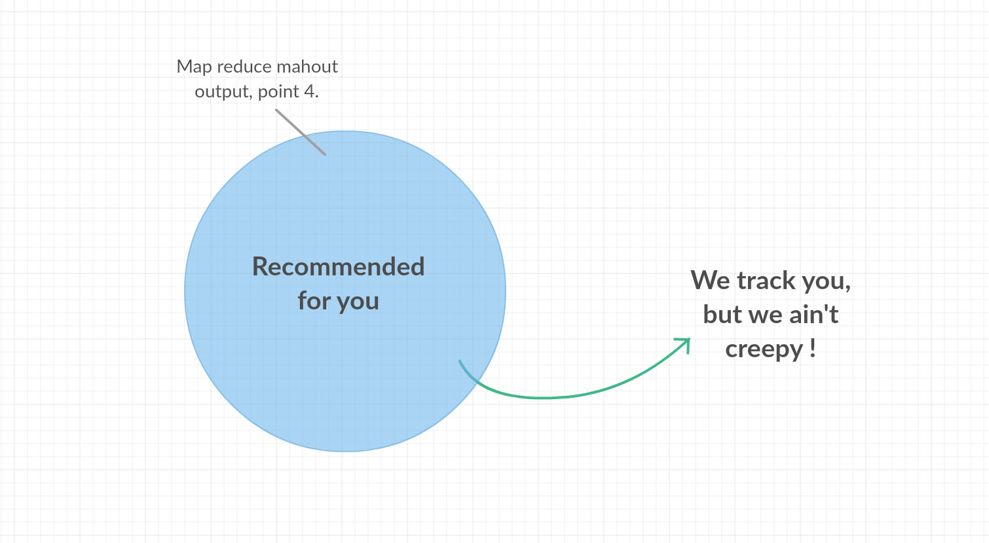

1. **We are hitting 2 API’s in our Platform, for filtering recommendations and suggesting a better Hybrid output, suggesting different playlists**
   1. **IBM Bluemix for Tone Analyzer**

We are creating a utility where we will fetch the user’s mood as an input in terms of smileys or a chat box

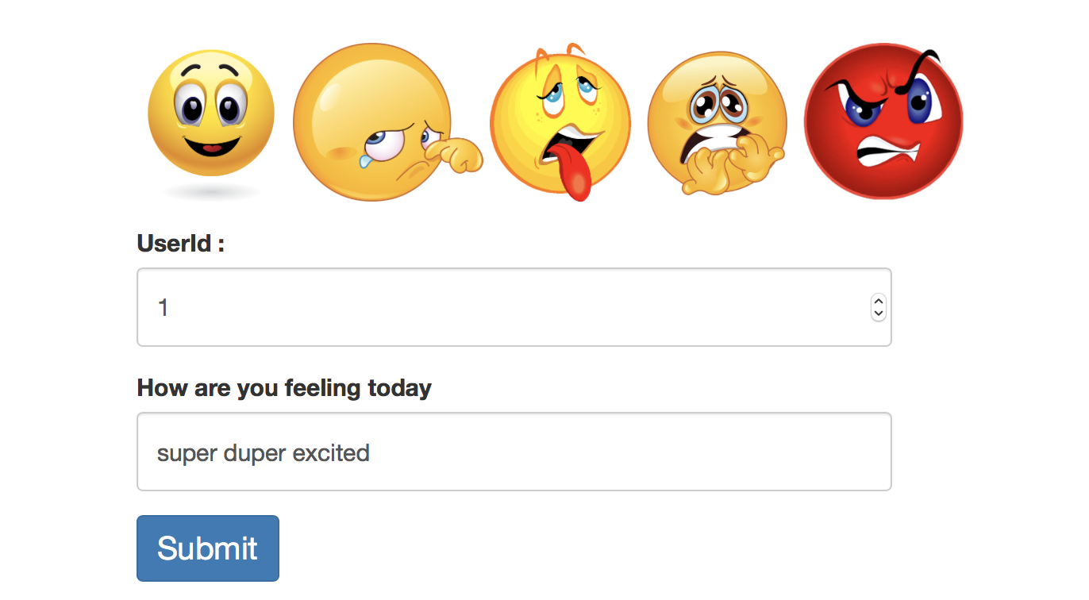

We will hit the blue mix to fetch the tone in terms of Tone

‘Fear’, ‘Joy’, ‘Angry’, ‘Disgust’, ‘Sadness’.

ToneAnalyzer service = new ToneAnalyzer(ToneAnalyzer.VERSION_DATE_2016_05_19);

service.setUsernameAndPassword("YOUR_KEY", "YOUR_AUTH");

ToneAnalysis tone=service.getTone(mood, null).execute();

* 1. **MusixMatch to fetch the lyrics of the songs on basis for ‘Track Id’ from Million Song Dataset**

We will be fetching the lyrics of the song to suggest the song accordingly hitting the same Tone Analyzer URL and write a java logic hitting mongoDb to filter out

**‘songs recommended -> and having mood as the same of user’**

String jsonUrl="http://api.7digital.com/1.2/release/details?releaseid=1625521&country=ww&oauth_consumer_key=KEY_HERE";

String jsonUrlString=callURL(jsonUrl);

1. **We are also running the triplet of [‘UserId, SongId, Playcount’] on Azure ML.**

Azure’s Machine Learning algorithm for recommendation is known as the ‘Matchbox algorithm’. There are two principal approaches to recommender systems.

1. The first is the **content-based** approach, which makes use of features for both users and items.
2. The second approach is **collaborative filtering**, which uses only identifiers of the users and the items and obtains implicit information about these entities from a (sparse) matrix of ratings given by the users to the items.
3. We can learn about a user from the items they have rated and from other users who have rated the same items, **much like the Mahout recommendation**.

Matchbox recommendation model built on ML studio

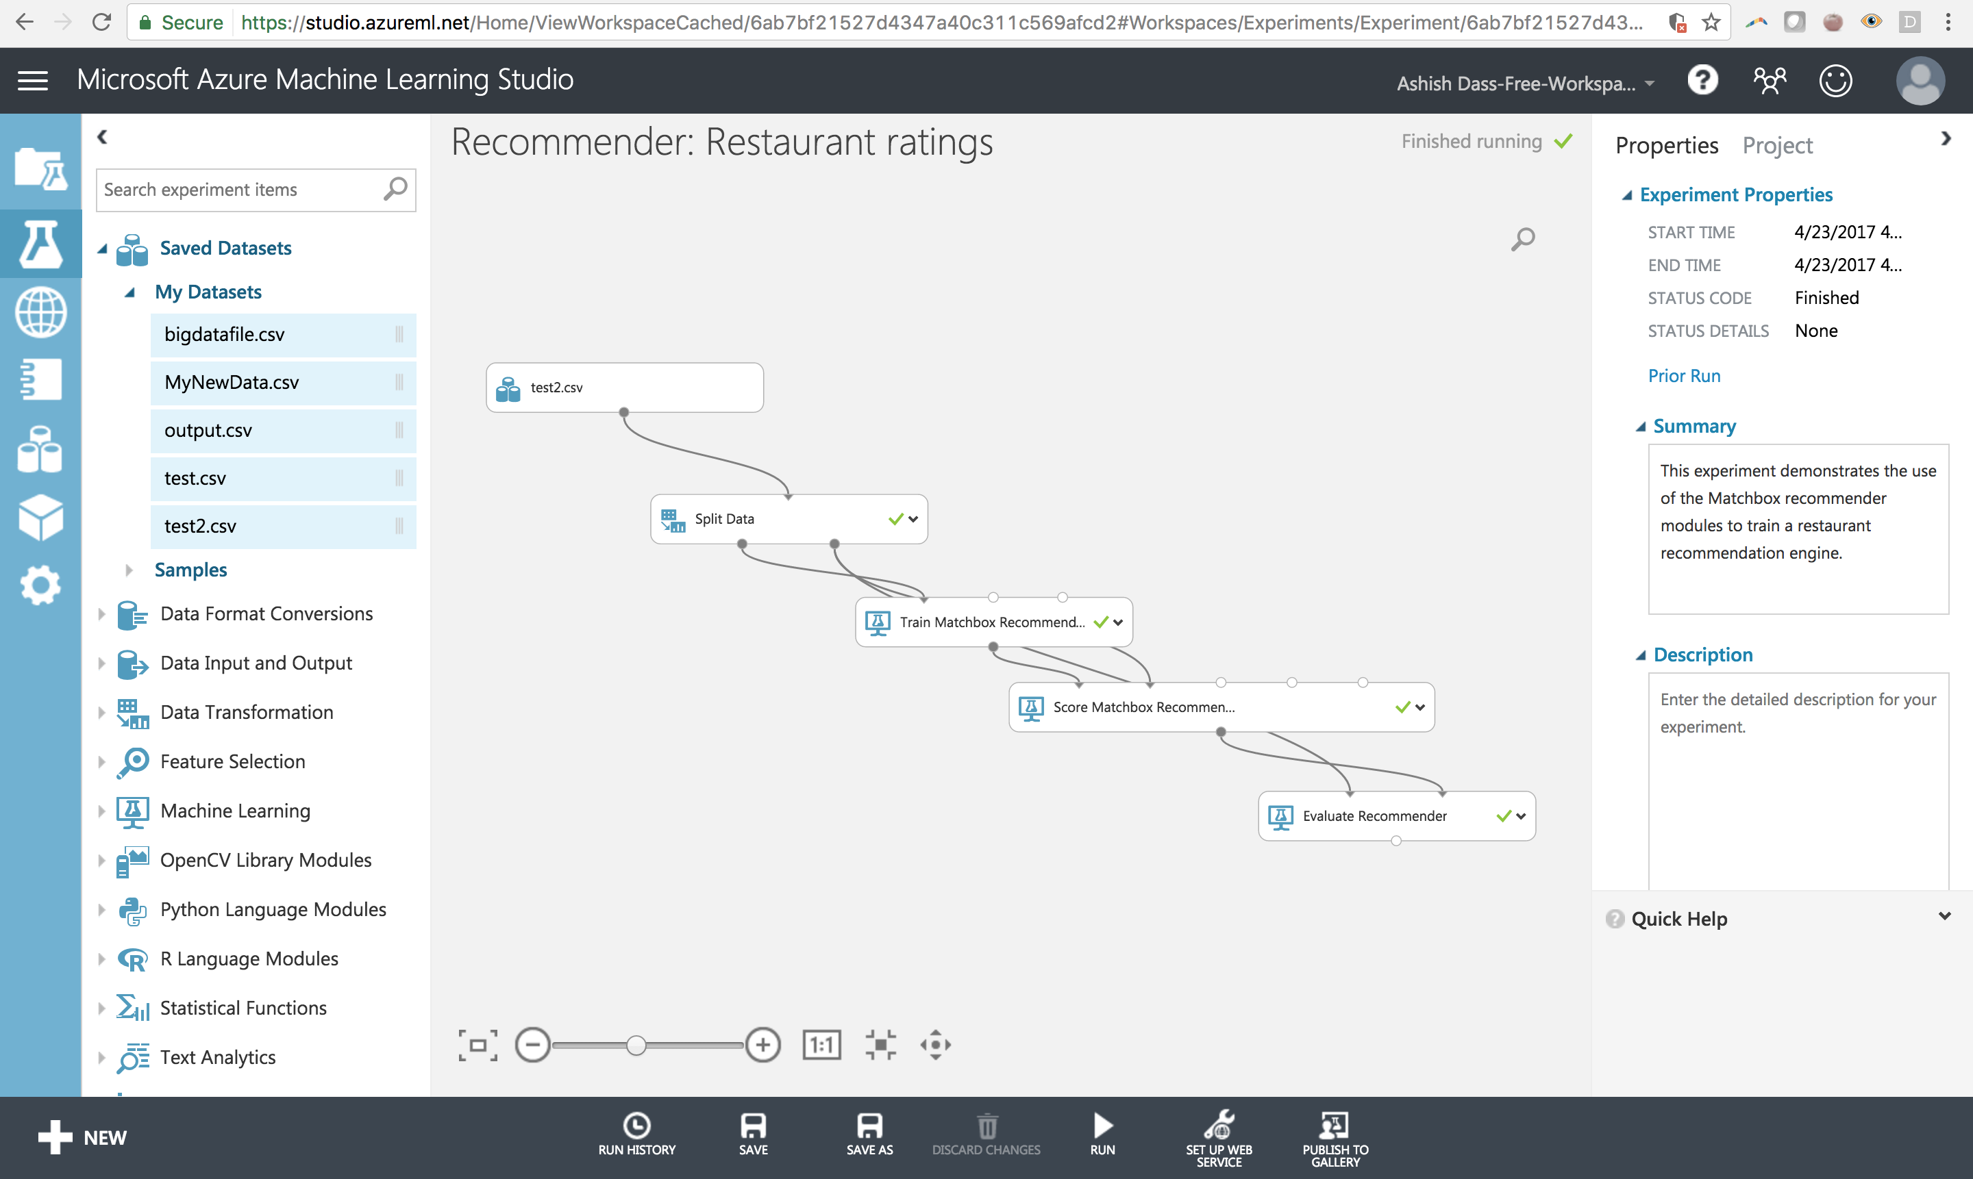

Recommendation results [5 values for each user]

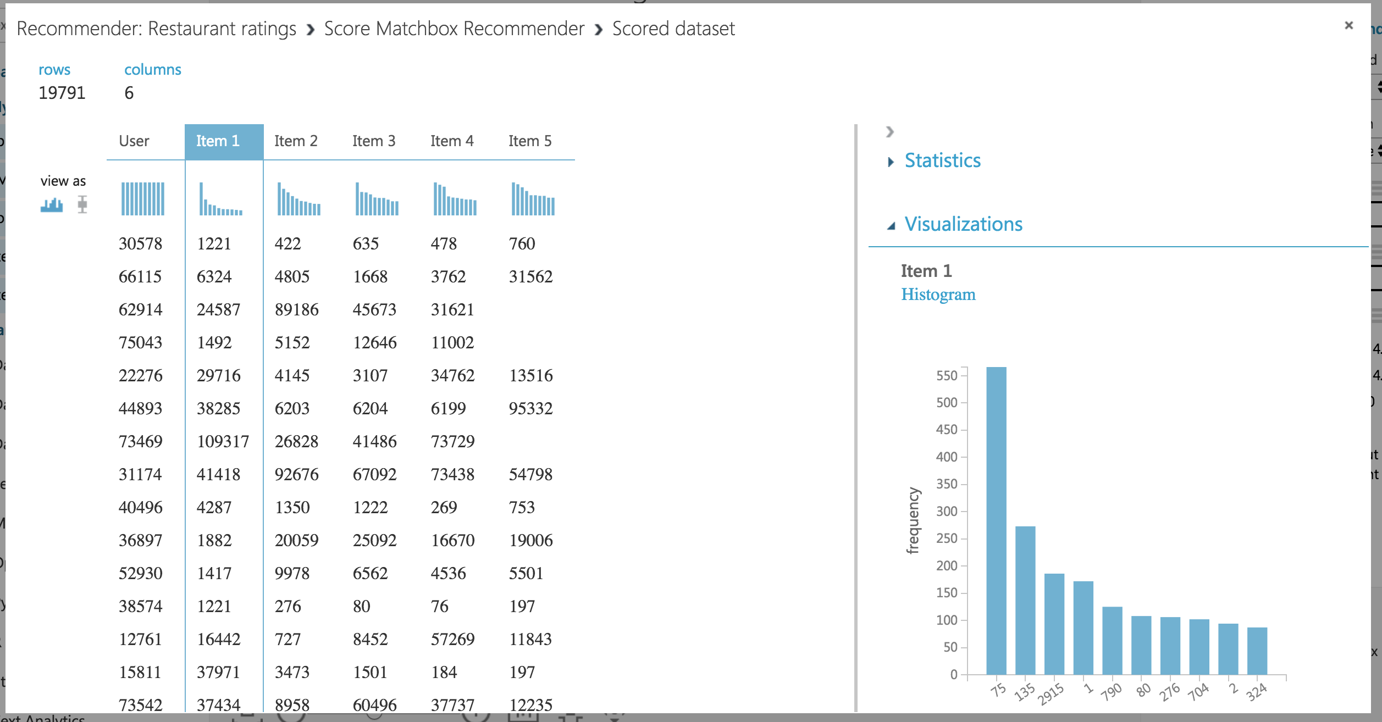

1. **Designed a platform to accommodate the entire BIG DATA PIPELINE**

**Because of humongous size of the data we had to execute a lot of Programs and Algorithms in the Pipeline on the Cloud for leveraging the computing resources**

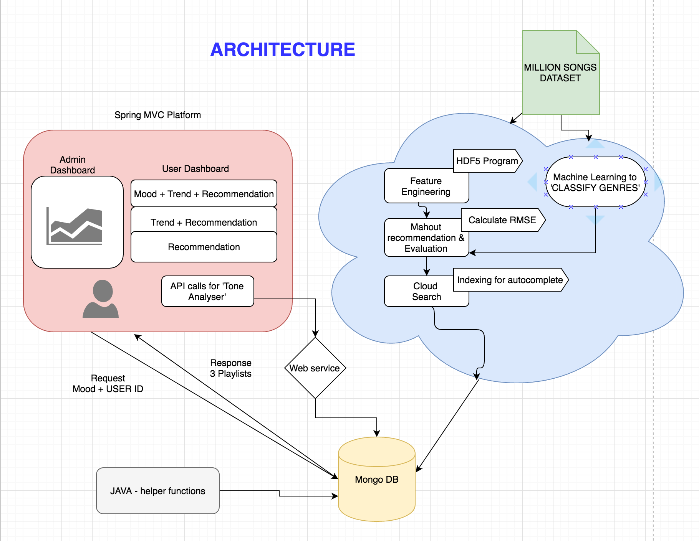

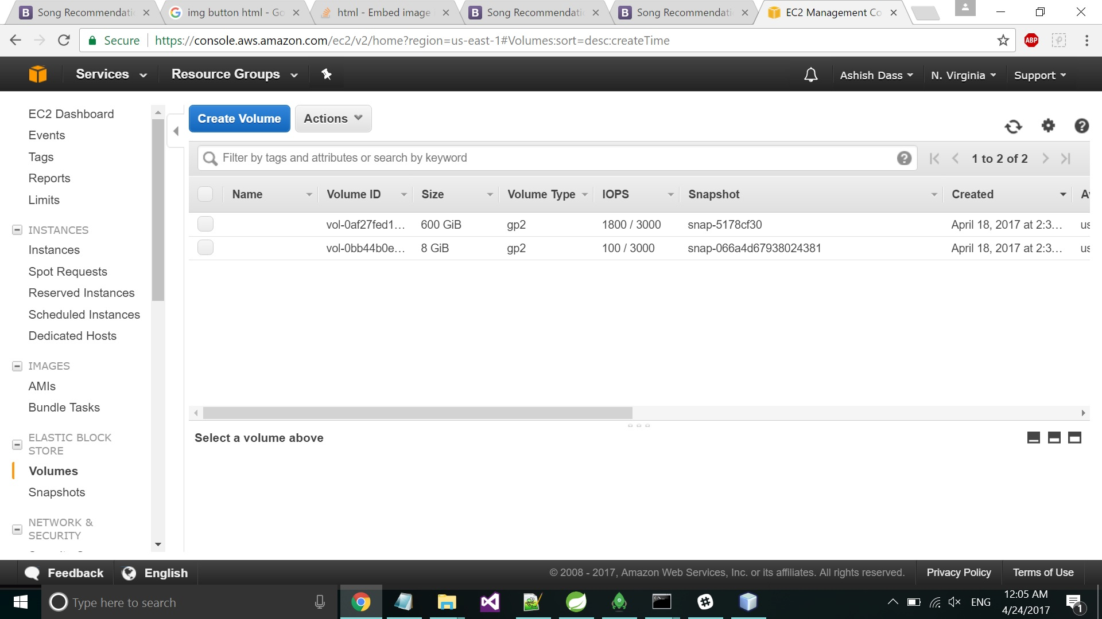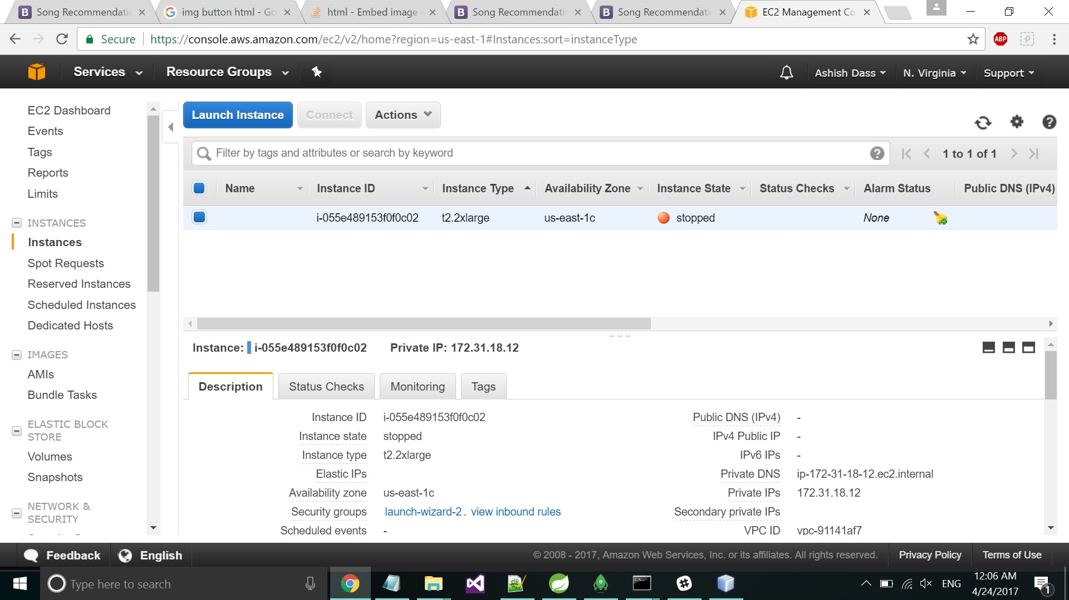

1. **Tableau Integration – Interactive Charts**

We have given a functionality for the admin to visualize everything that is happening with the data and perform rudimentary analysis.

**9.1 Artists belonging to locations (size – No. of artists) & (Color – cities/regions)**

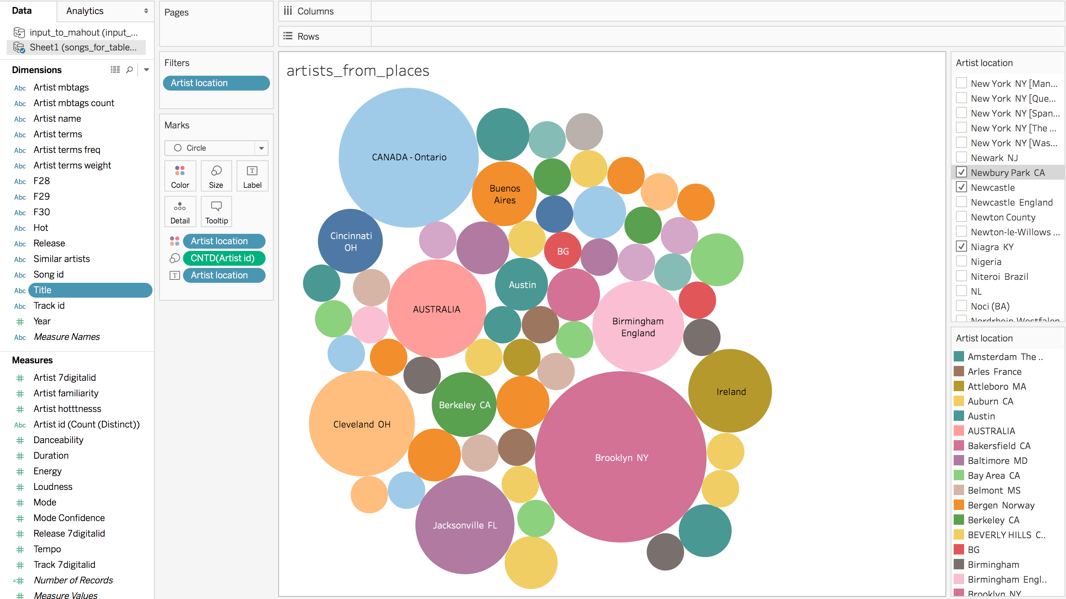

**9.2 Customer acquisition and targeting ad groups based on premium usage of app (size – Songs heard) & (Color – songs)**

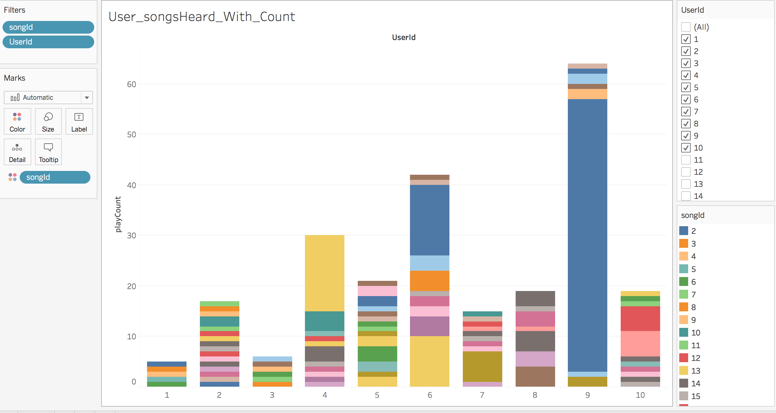

1. **Machine Learning for Genre classification of the songs**

**Python code to generate genre classification –**

The idea is to use artist tags in the MSD that describe typical genres. From the artists tagged by these, we extract simple features from all their tracks. The Echo Nest terms are a little too complicated and diverse to be used for that purpose. To get a handful of genres, we would have to handpick a large number of tags and merge the related ones into genres classes. For instance, 'us pop', 'pop', 'indie pop', 'American pop', ... could all be merged into 'pop'.

This could also be improved.



1. **FUTURE SCOPE**

**ARIMA based model fitted to ‘Time Series’ data**, either to better understand the data or to predict future points in the series (forecasting).

ARIMA models are applied in some cases where data show evidence of non-stationarity, where an initial differencing step can be applied one or more times to eliminate the non-stationarity.

* 1. **Collection of Situational/Contextual Data –** listener’s activity while listening to the song like (exercising, driving, partying, etc.).
  2. **LIMITATION –** of historical data

We had data only for the user preference in the form of ‘Play Count’ which was simulated in a number of ways to be offered as ‘Ratings’.

We did not have any historical data of the song/track being heard.

* 1. **SOLUTION –** doing **ARIMA based modelling for better prediction based on ‘TIME’ and ‘WEATHER’.**

If we could get the additional info of user history in the form of ‘MM/DD/YYYY HH:MM:SS’, we could probably find out ‘SEASONALITY’ & ‘TREND’ of the data.

Also, if we could integrate the ‘weather’ around the area it could be used in ‘feature engineering’ as an independent variable for better machine learning algorithms, ARIMA being one of them to capture the seasonality in this case.

Since, **Differencing** in statistics is a transformation applied to time-series data in order to make it stationary.

The method of differencing data is **seasonal differencing**, which involves computing the difference between an observation and the corresponding observation in the previous year. This is shown as:

{\displaystyle y_{t}'=y_{t}-y_{t-m}\quad {\text{where }}m={\text{number of seasons}}.}

**The differenced data is then used for the estimation of an ARMA model.**

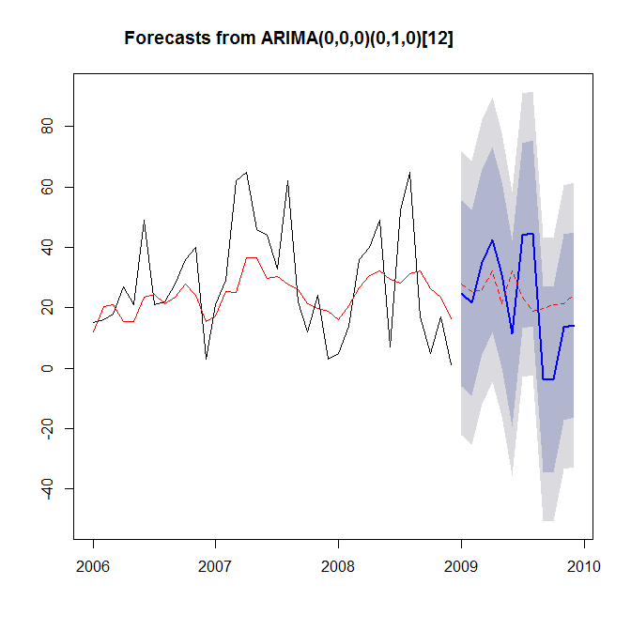

* 1. **NEED OF STANDARDIZED DATA SETS –** and a common goal or objective for evaluating such techniques and models.